April 11, 2015

Alexandra Phillips, Bicycle Recreation Specialist
Oregon Parks and Recreation Department
725 Summer Street NE Suite C
Salem, OR 97301

Dear Ms. Phillips,

I support the proposed Cascade Siskiyou Scenic Bikeway. It is a beautiful but strenuous route. The contemplated characterization of the CSSB as an “adventure route” is appropriate.
Of the approximate 250 Siskiyou Velo bike club members only an estimated 10 to 20 percent rode the route in the last year. That speaks volumes about the physical demands that the climbs require as well as the mastery of the “rules of the road” and advanced bicycle riding skills. With the narrow highways and fast, sustained descents only skilled cyclists will find the route enjoyable.

I’ve attached a set of traffic safety recommendations that, I hope, will be implemented as a part of the SCSB designation. However, whether the CSSB is designated or not, the traffic safety measures are needed to ensure that motorists and people riding bicycles drive their vehicles consistent with Oregon laws.

Thank you,
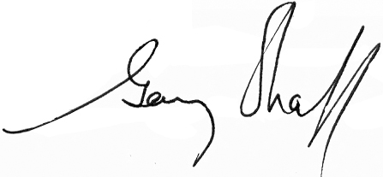
Gary Shaff
President, Siskiyou Velo
LCI #3864

Lakes Loop
Traffic Safety Improvements

The ‘Mountain Lakes Loop’ is a difficult and windy route without shoulders. I don’t believe I have every ridden the route without a least one motor vehicle driver violating ORS 811.065, Unsafe Passing of a Person on a Bicycle. Other cyclists that I have spoke with suggest that number of illegal passes is much higher; as high as four out of five motor vehicles.

It is very rare that close passes are malicious. When it's easy to leave a lot of space, a large majority of drivers do. When it's more difficult, on narrow roads, with oncoming traffic, blind bends, or blind rises, too many drivers decide to overtake even though they can't leave an appropriate amount of space. I also believe that many drivers just aren't aware of how much space they should leave, and don't realize how intimidating it can be to pass close and fast.

The issue is often compounded by inexperienced cyclists riding too close to or at the edge of pavement. With this lane position they invite motorists to squeeze past; between the cyclists and the center line strip. The lane widths on the Greensprings and Dead Indian Memorial Highways are 11 feet wide (with less than 12 inch shoulders). That is too narrow to be safely shared by two vehicles (i.e. two vehicles in a single lane), even when one of them is a bicycle. (Note: see photo at Travel Oregon’s CSSB for an example of poor biyclist’s lane position).

When cyclists do take the proper lane position, some drivers become aggressive and yell as they overtake the cyclists. This too is a violation of Oregon law (see ORS 166.065, Harassment). Fortunately, here again, it happens rarely but when it does it is very disconcerting. Possibly a sign that says “bicyclist can use entire lane” might help.

There is also wide spread ignorance of the provisions of ORS 811.420(3)(b) allowing auto drivers to pass bicycles in a “no-passing” zone. Taken together, ORS 811.065 and 811.420 make it reasonable for bicycle drivers and motor vehicle drivers to share the road. That said, sharing the road in ignorance of the applicable laws does not work.

There are three things that I would recommend be done to improve traffic safety within the Lakes Loop (i.e. proposed CSSB).
- Erect “bikes on roadway next 8 miles” signs (10 miles in the case of Dead Indian Memorial Highway) at the base of the grades. The signs could rely upon video detection (or a push button which cyclists would press) that would illuminate Rapid Flash Beacons (RFB’s) which would flash for a specified time (probably upwards of an hour) – the time it would take a slower cyclists to reach the top. I would recommend that the buttons, if video detection isn’t possible, be placed at the intersection at Buckhorn Springs and OR66, and near the Ashland Airport on Dead Indian Memorial Highway. The OR66 location coincides with where cyclists often stop to remove extra layers of clothing or grab a quick snack before beginning the 7.5 mile climb to the top of the Greensprings Grade.

- Place signs throughout the route (not just on OR66) explicitly showing the requirements of ORS 811.065 (see below).

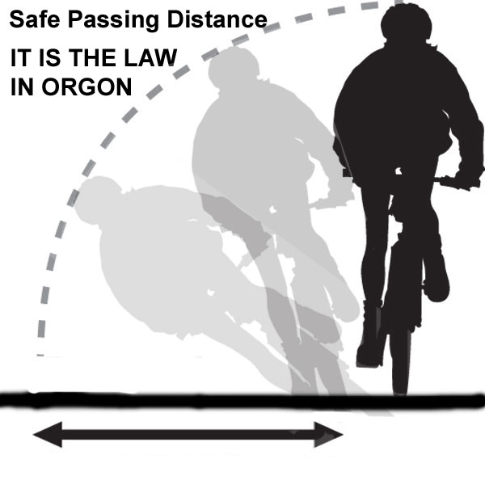
This sign is superior to the “share the road” signs. The term “share the road” implies that it is a nice thing to do (much like asking a young child to share their toys). But passing a cyclist or obeying the speed limit isn’t about being nice, it is the law in Oregon.

There is a short distance along the CSSB route where the above sign would be improper; a short section of OR66 between the I5 interchange and Crowson Road in Ashland where ODOT recently added bike lanes. Other than this short section and the few roads that are entirely within the Ashland City limits, there are no other streets/roads/highway along the route with designated bike lanes.

- Design and place signs illustrating the provisions of ORS 811.420(3)(b).

Ultimately, any State action must contribute to “vision zero” and the elimination of deaths due to collisions between people who walk or ride bicycles, and motor vehicles.

Sincerely,
Gary Shaff
President, Siskiyou Velo
LCI #3864

